***SYSTEM USER GUIDE***

*Table of Contents*

**Introduction** 3

***Package Description*** 3

**Hardware and Software requirements** 4

***Required hardware*** 4

***Minimum software requirements*** 4

**Installing the system** 5

**Backup Procedures** 8

***Backing up the system*** 8

***Closing the system*** 11

**Operating Instructions** 12

***How the menu system works*** 12

***Adding a new member*** 13

***Adding a new medical condition*** 18

***Processing a new order*** 20

***Adding a membership tier*** 26

***Adding a new product*** 28

***Adding a new staff member*** 31

***Archiving orders*** 33

***Viewing a report*** 36

***Printing a report*** 38

**Frequently Asked Questions** 39

**Contact details** 42

# **Introduction**

Welcome to the official user guide of Beltel’s new system. This guide has been designed for your convenience, with step-by-step instructions on how to use everyday features as well as frequently asked questions to help you use the system to its full potential.

## ***Package Description***

Our new system has been designed to enhance day-to-day operations and improve the experience for our members. Data is organised and stored in a working database which allows to keep track of specific data. For your convenience, a menu system is provided to allow for easy navigation and so that data can been accessed quickly – in this case, that is extremely crucial in a busy working environment like Beltel.

The system offers various features – the ordering system allows you to not only add and process orders, but calculations regarding item totals and discounts are automatically done for you! In addition, you can also add/edit member, product, order, membership, medical and product details, which then can be used to print reports so that specific data regarding Beltel’s operations can be analysed. There is also the archive process that allows for old orders to be deleted to speed up the system.

Unsure of what to do? Fret not! Contact details are provided at the back of this guide; please feel free to send us an email or call us if you have any queries.

# **Hardware and Software requirements**

## ***Required hardware***

Specific hardware will be required when performing special tasks; these include:

* Desktop computers, complete with a monitor, and keyboard and mouse, that can support and run the latest versions of Microsoft Access/365.
* Printers capable of colour printing, copying, scanning, and faxing.
  + This is ideal for reports.
  + In addition, a printer with Wi-fi functionally to enable wireless printing.
* Apple iPads that are designed for placing orders. In addition, a card reader that supports contactless cards (and Apple/Google Pay) to process orders and authorise transactions.
  + This also includes a printer that supports the Apple Airprint feature to enable the iPads to print receipts wirelessly.
* External webcams for holding video calls and meetings.

## ***Minimum software requirements***

This system uses Microsoft Access, which is part of the Microsoft 365 group of applications. As such, the following software requirements to run the system are detailed below:

* **Computer and processor**: 1.6 GHz or faster, 2-core. 2 GHz or greater recommended for Skype for Business.
* **Memory**:4 GB RAM (64-bit) or 2 GB RAM (32-bit)
* **Hard disk:** 4GB of available disk space.
* **Resolution:** 1280 x 768 screen resolution (32-bit requires hardware acceleration for 4K and higher). Web apps require the same minimum resolution as the OS they are running on. In addition, apps running inside of Microsoft Teams adhere to the application’s minimum resolution.
* **Graphics:** DirectX 9 or later required for graphics hardware acceleration. Skype for Business requires DirectX 9 or later, 128 MB graphics memory, and 32-bits-per-pixel-capable format.
* **Operating System**: Windows 11, Windows 10, Windows 8.1, Windows Server 2019, or Windows Server 2016.
* **Browser (for web apps):** The latest versions of Microsoft Edge, Chrome, or Firefox.
* **Other:** Microsoft Edge WebView2 must be installed to use additional Outlook features.
* **Video calls and meetings:** A 2 GHz processor with 4GB RAM or higher is recommended. The optional blurred background effect requires a processor with Advanced Vector Extensions 2 (AVX2) support.
* **Teams live events:** For holding live events, an Intel Core i5 Kaby Lake processor with 4GB RAM and a hardware decoder is recommended.

# **Installing the system**

As part of the software package, a USB memory stick should be distributed to allow for installation on your computer. If you haven’t already, find your USB stick *(If you cannot find your USB stick, please contact us using the details on the back of this guide)*, then follow the instructions below:

1. Locate the USB port. It should be found on the front/back of the computer.



1. Insert the USB memory stick into the USB port. You should hear a sound; this tells you that the computer is now connected to the USB stick.
2. Now we will locate the Beltel Microsoft Access file (it is called **“Beltel Database.accdb”**).
   1. Open File Explorer (the folder icon).
   2. On the left-hand side, select “This PC” followed by the USB icon named “BELTEL”.
   3. Open the folder called “Software Package” – this is where the file is stored.
   4. Graphical user interface, text, application, chat or text message

      Description automatically generatedGraphical user interface, application

      Description automatically generatedRight-click on the file and select “Copy”.

The USB where the database file is stored.

1. Select “This PC” again, select the hard disk icon, then right-click and select “Paste” in the desired location.

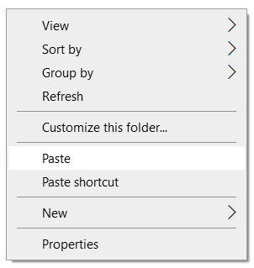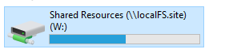

1. Double-click the database file to open it. If you receive a message about a security risk, do not worry.
   1. Exit the database by clicking the **x** icon at the top right of the screen.
   2. Select the file and right click. Then select “Properties”.
   3. At the bottom of the General section, you’ll see a message regarding security. Click the box that says “Unblocked” so that it is ticked. Then click the “Apply” button which enables you to use the order archive feature.



1. If you receive a message about a security warning, do not worry as this is normal. Simply click “Enable Content”.

*The database is now ready to be used!*

# **Backup Procedures**

## ***Backing up the system***

A data backup is a copy of data that is stored in an alternative location different than the place it’s currently being used. It is recommended that the system is backed up weekly to minimalize data loss in the event of, for example, a system crash. Otherwise, problems will arise in the case of missing orders which will result in lost profits.

As such, a copy of the database will be created on an USB memory stick and taken offsite by management, who will store the backup in a physical location such as a safe.

To back up the database, you must do the following:

1. Locate where you have stored the database file on your hard disk.

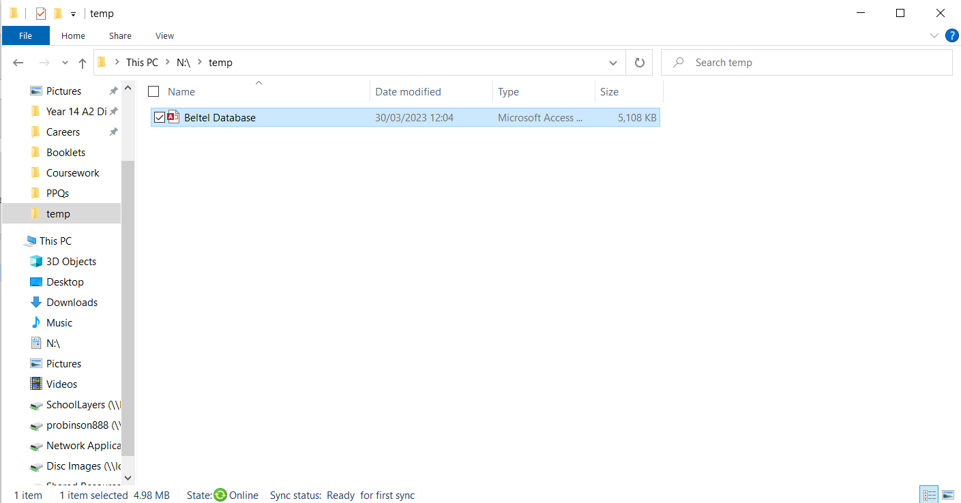

1. Insert the USB memory stick you’ll use to store the backup into the USB port.



1. Right-click on the database file and select “Copy”.

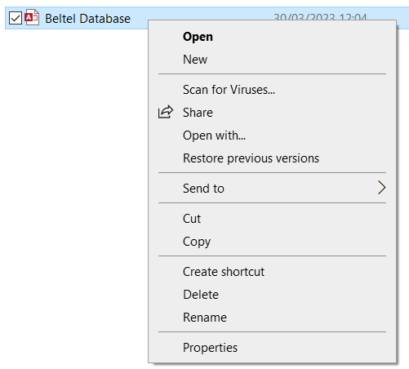

1. 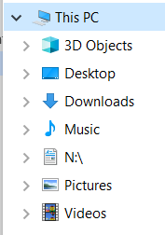On the left-hand side of File Explorer, select “This PC” and select the USB icon.
2. 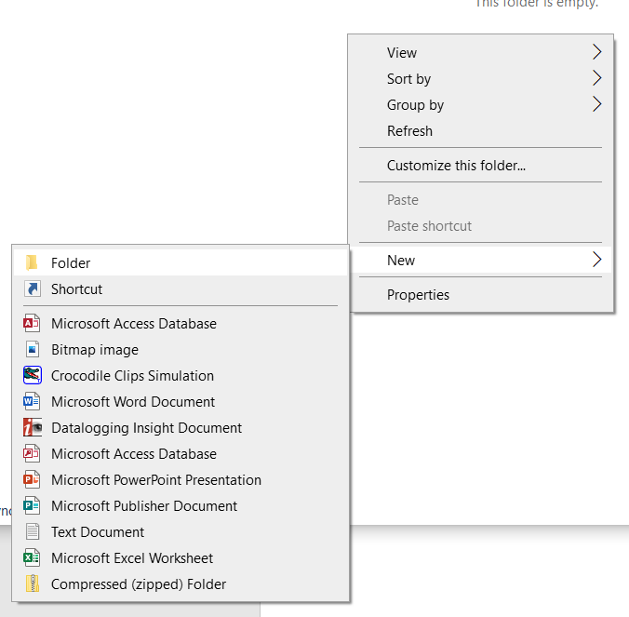Then right-click, select “New” then “Folder”. Name the folder “Beltel Database Backup”.



1. In your new folder, right-click and select “Paste”. A copy of the database should now appear.



1. 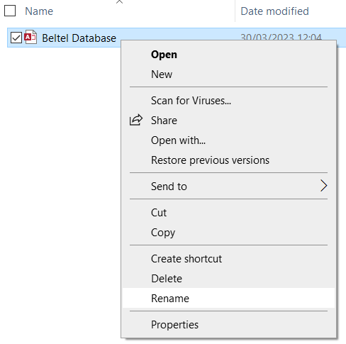We will now rename the copied file.
   1. Select the file, right-click, and select “Rename”.
   2. It is recommended that you include the date of the backup. For example, **“Beltel Database Backup (30 Mar 23)”.**

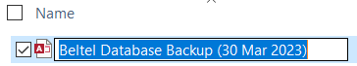

The file has now been renamed

*The database copy is now ready to be taken offsite!*

## ***Closing the system***

Exiting the system is as simple as this:

1. At the top right of the screen, click the **x** icon.
2. 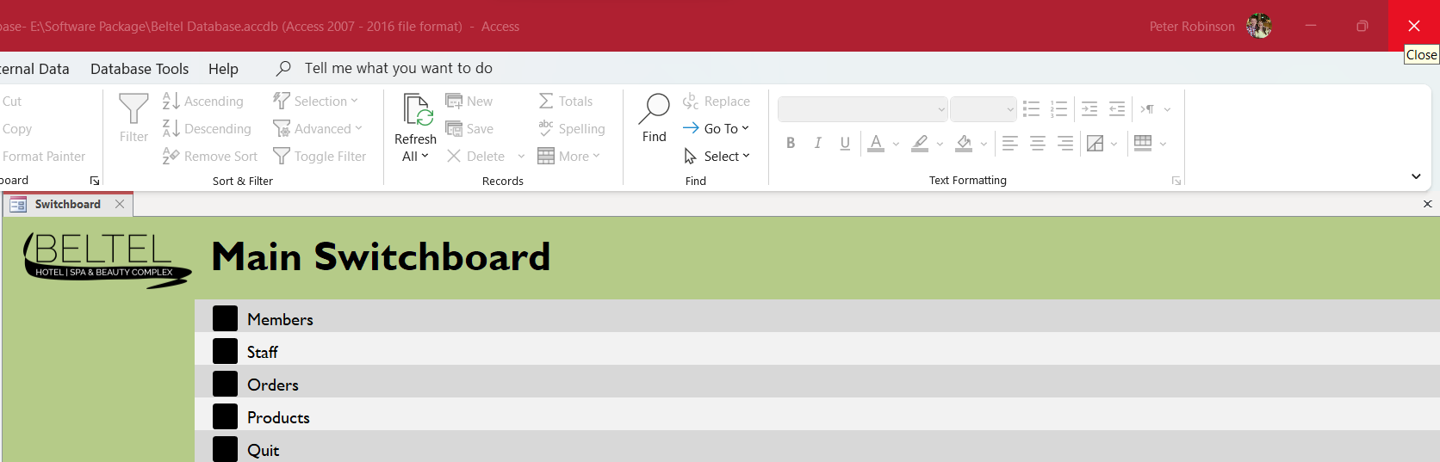Should you be asked if you would like to save your work, select “Yes.”

# **Operating Instructions**

## ***How the menu system works***

Detailed below is how the menu system is laid out when you open the database:

**Main Menu**

* Members – This takes you to the Member Menu
* Staff – This takes you to the Staff Menu
* Orders – This takes you to the Order Menu
* Products – This takes you to the Product Menu
* Quit – This closes the database

**Member Menu**

* View Member Details – This opens the member form and allows you to view details of all members
* View membership details – This opens the membership form and allows you to view membership details of each tier
* View medical conditions – This opens the medical form and allows you to view medical details
* View members with medical conditions – This opens the members with medical conditions report which allows you to view members suffering from medical conditions
* Add New Member – This opens the member form and allows you to add new members
* Add membership tier – This opens the membership form and allows you to add new membership tiers
* Add new medical condition – This opens the medical form and allows you to add new medical conditions
* Back – This returns you to the main menu

**Staff Menu**

* View Staff Member Details – This opens the staff form and allows you to view details of all staff members
* Add Staff Member Details – This opens the staff form and allows you to add new staff members
* Back – This returns you to the main menu

**Order Menu**

* View Orders – This opens the main order form and allows you to view details of all orders
* Add New Order – This opens the main order form and allows you to process new orders
* Archive Old Orders – This runs the order archive process
* View Restaurant Performance – This opens the monthly sales report, allowing you to analyse the sales made by the restaurant every month of each year
* View Invoices – This opens the invoice report, allowing you to view unpaid orders and who has yet to pay
* View Receipts – This opens the receipt report, allowing you to view paid orders, what was ordered and how much they paid
* View most used payment methods – This opens the most used payment methods report, allowing you to analyse what’s the most frequent payment method when placing an order
* Back - This returns you to the main menu

**Product Menu**

* View Products – This opens the product form and allows you to view details of all products available at the restaurant
* Add New Products – This opens the product form and allows you to add new products for the restaurant
* View best-selling products – This opens the best-selling products report, allowing you to analyse the best-selling dishes at the restaurant
* Back – This returns you to the main menu

## ***Adding a new member***

1. On the main menu, select the “Members” button.

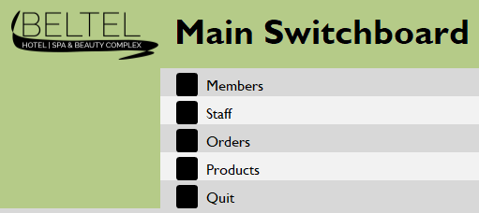

1. You should be taken to the Member Menu. Now select “Add New Member”.

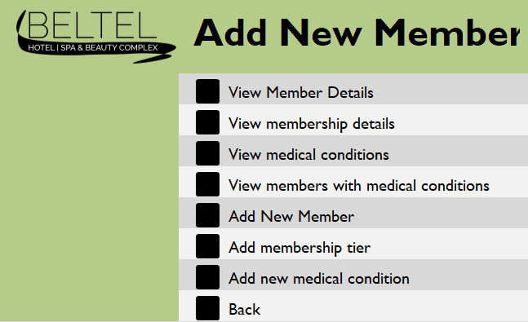

1. Once selected, the member form should open displaying blank boxes. Don’t enter anything just yet.

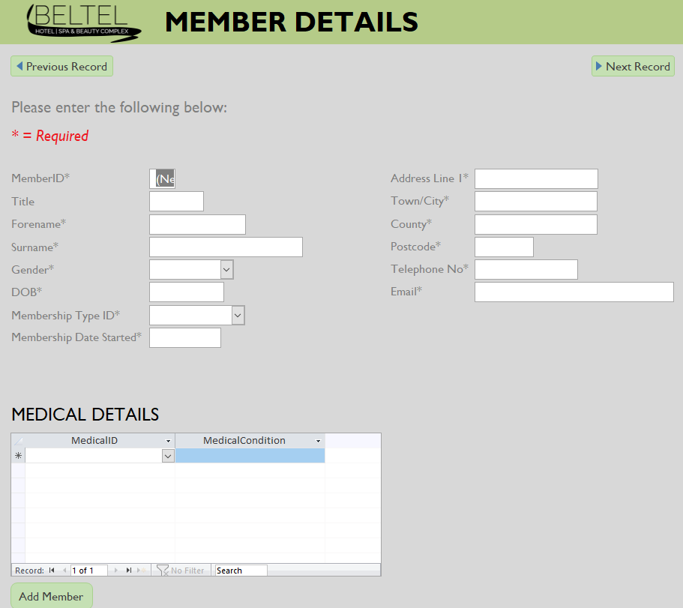

(1)

(2)

Focus your attention on the following boxes, otherwise you may receive an error message:

1. Graphical user interface, application

   Description automatically generated**Member details:**

* **MemberID** – This box is required. However, **don’t** enter anything as it will fill in automatically when entering data into the other boxes.
* **Title** – This box **isn’t** required but please be aware that only 4 letters can be entered.
* **Forename** – This box is required and only allows 20 characters to be entered.
* **Surname** – This box is required and only allows 25 characters to be entered.
* **Gender** – This box is required but be aware that you can only select items from the drop-down list. You cannot enter Boy, Girl etc. This can be accessed by clicking the ↓ icon on the right.
* **DOB** – This box is required and only accepts a certain format. In this case, DD/MM/YYYY (D for day, M for month and Y for year).
* **MembershipTypeID** – This box is required but be aware that you can only select items from the drop-down list. This can be accessed by clicking the ↓ icon on the right. Only numbers can be entered, so no “Bronze” or “Gold”.
* **Membership Date Started** – This box is required and only accepts a certain format. In this case, DD/MM/YYYY (D for day, M for month and Y for year).
* **Address Line 1** – This box is required and only allows 20 characters to be entered.
* **Town/City** - This box is required and only allows 45 characters to be entered.
* **County** - This box is required and only allows 30 characters to be entered.
* **Postcode** - This box is required and only accepts a certain format. In this case, L?09 0LL – this means that you must enter a required letter, then an optional letter, a required number, an optional number then another required number followed by two required letters. Only 7 characters can be entered.
* **Telephone No** - This box is required and only accepts a certain format. In this case, 00000 000000 – this means that you must enter 11 required numbers. Including the space, only 12 characters can be entered.
* **Email** - This box is required and only allows 40 characters to be entered.

1. 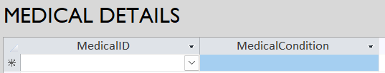**Medical details - These boxes below are only required if the member suffers from a medical condition.**

* **MedicalID** – You can only select items from the drop-down list. This can be accessed by clicking the ↓ icon on the right. Only numbers can be entered, so no “Five” or “ADHD”.
* **MedicalCondition** – This box will be automatically filled in depending on the Medical ID. For example, selecting “13” in the drop-down list results in “Peanut Allergy” being entered immediately.

1. Now enter the details required using your keyboard and mouse. By the end, it should look something like this:

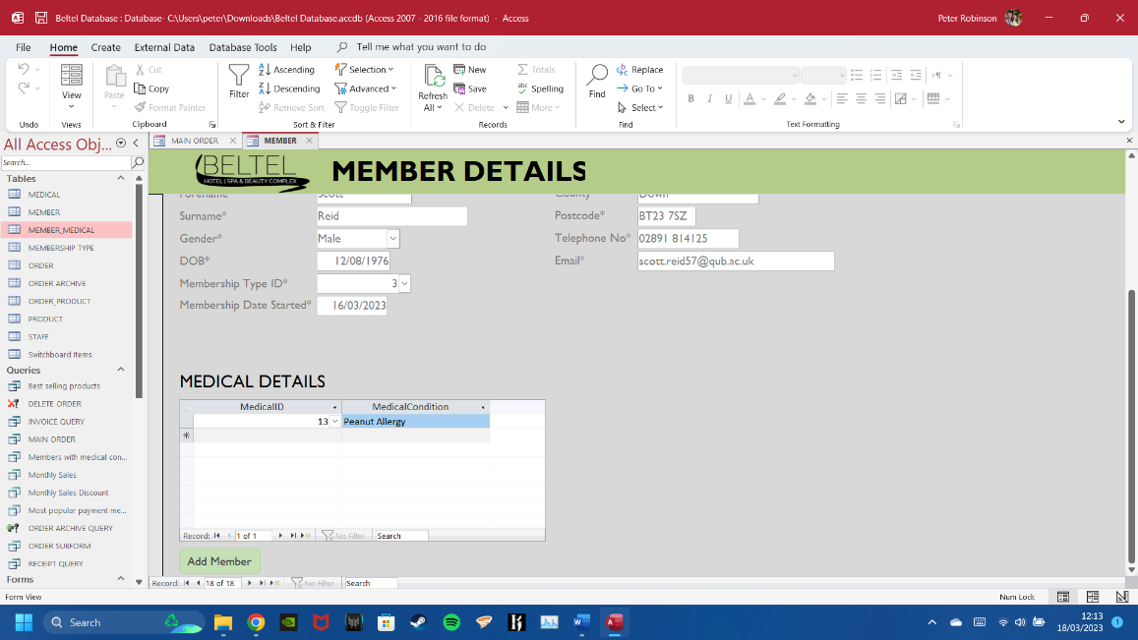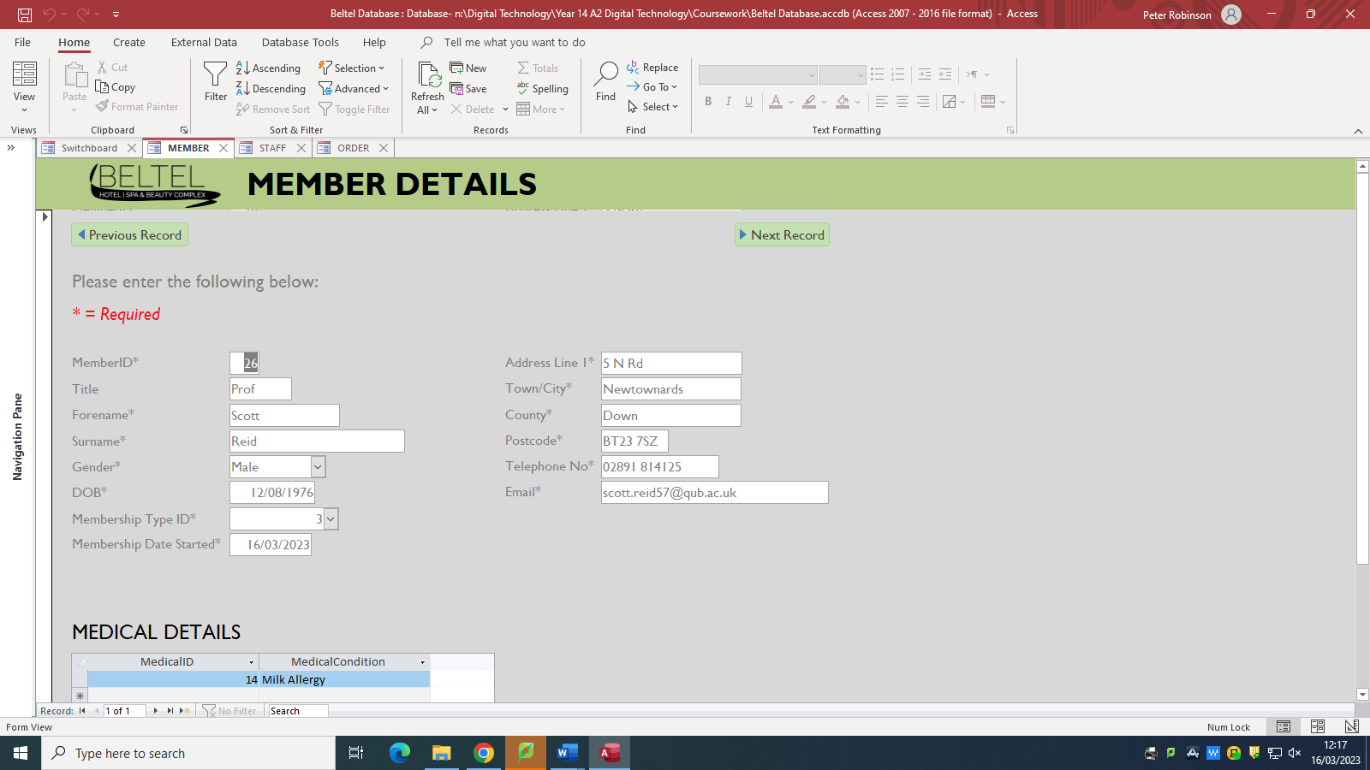

1. Now we will save this member’s details. Located at the bottom of the form is the “Add Member” button. Click it, and if you’ve done everything right, it should now be stored permanently in the database.

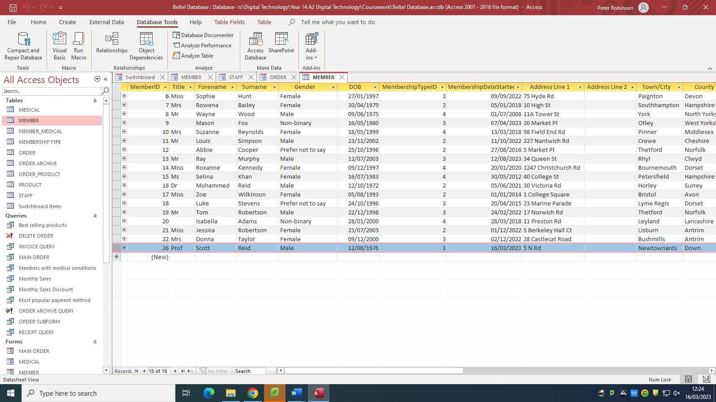

Professor Scott Reid is now stored in the MEMBER table.

1. Also note that at the top of each form there are navigation buttons. These allow you to view other records (in this case, other member details).

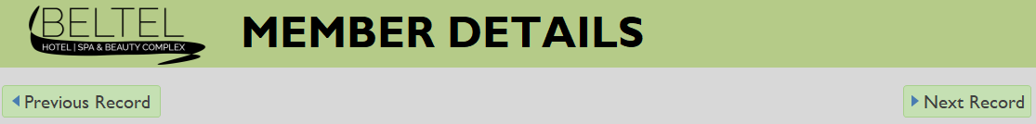

*You can return to this form by selecting “View Member Details” in the Member Menu. When editing these details, they will be saved automatically – refer to the instructions above on how to do so correctly.*

## ***Adding a new medical condition***

1. On the main menu, select the “Members” button.



1. You should be taken to the Member Menu. Now select “Add new medical condition”.



1. Once selected, the medical form should open displaying blank boxes. Don’t enter anything just yet.

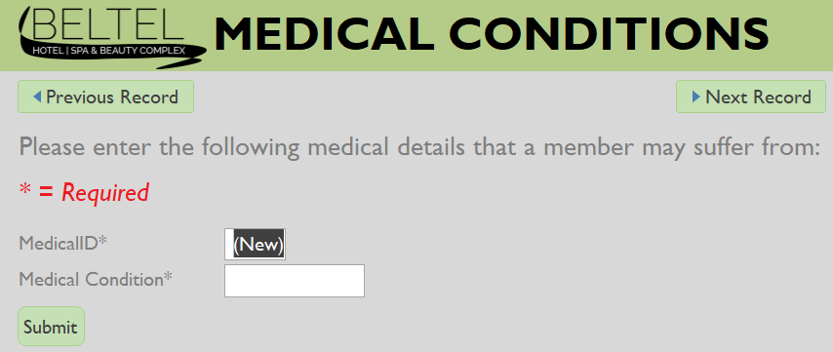

Focus your attention on the following boxes, otherwise you may receive an error message:

* **MedicalID** – This box is required. However, **don’t** enter anything as it will fill in automatically when entering data into the Medical Condition box.
* **Medical Condition** - This box is required and only allows 50 characters to be entered.

1. Now enter the details required using your keyboard and mouse. By the end, it should look something like this:

1. Now we will save this medical condition’s details. Located at the bottom of the form is the “Submit” button. Click it, and if you’ve done everything right, it should now be stored permanently in the database.

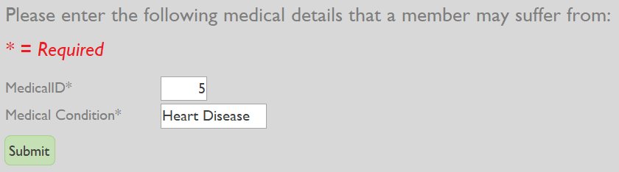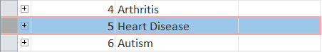

The medical condition “heart disease” is now stored in the MEDICAL table.

*You can return to this form by selecting “View medical conditions” in the Member Menu. When editing these details, they will be saved automatically – refer to the instructions above on how to do so correctly.*

## ***Processing a new order***

1. On the main menu, select the “Orders” button.



1. You should be taken to the Order Menu. Now select “Add New Order”.

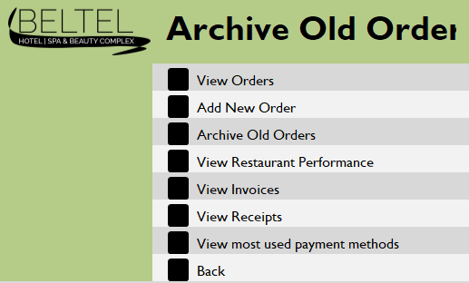

1. Once selected, the main order form should open displaying blank boxes. Don’t enter anything just yet.

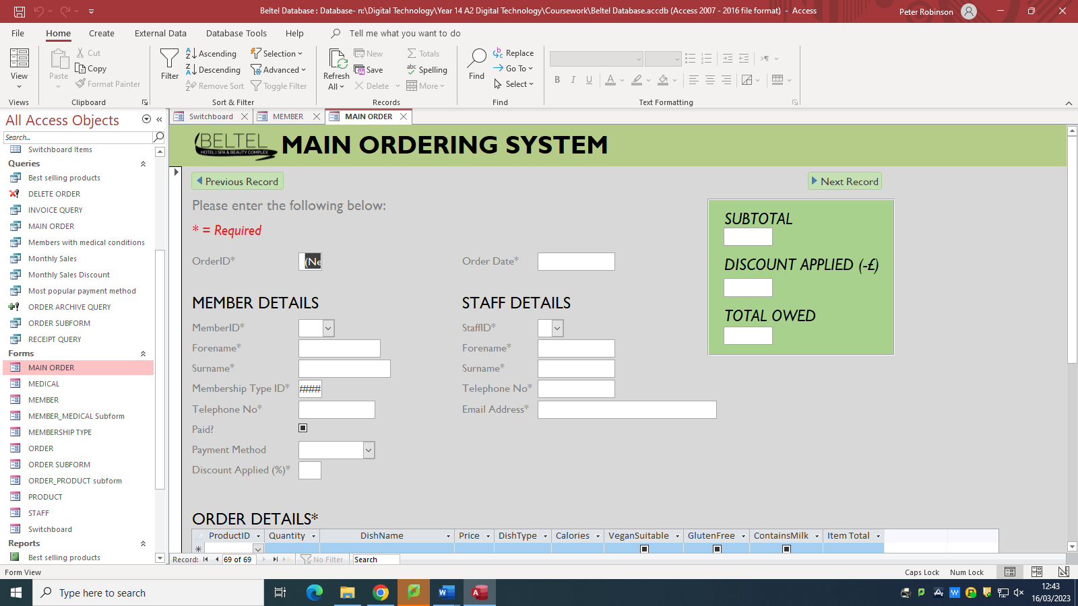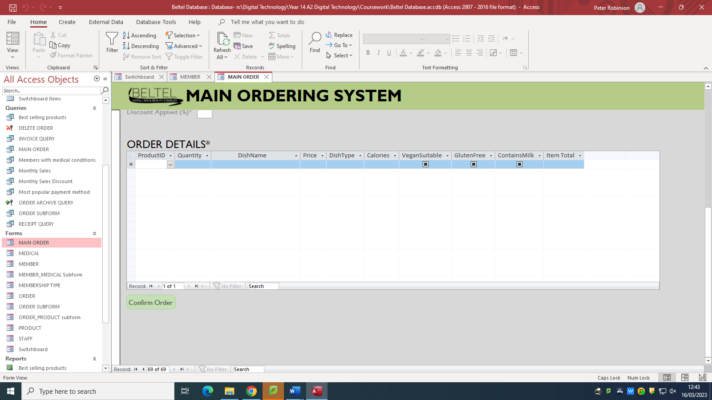

(1)

(4)

(5)

(2)

(3)

Focus your attention on the following boxes, otherwise you may receive an error message:

1. **OrderID & Order Date:**



* **OrderID** – This box is required. However, **don’t** enter anything as it will fill in automatically when entering data into the other boxes.
* **Order Date** – This box is required and only accepts a certain format. In this case, DD/MM/YYYY (D for day, M for month and Y for year).

1. **Member details**

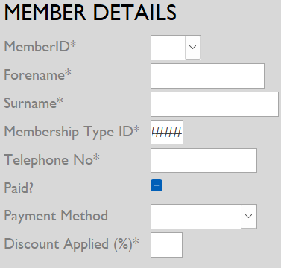

* + **Table

    Description automatically generatedMemberID -** This box is required but be aware that you can only select items from the drop-down list. You cannot enter 90, 107 etc. This can be accessed by clicking the ↓ icon on the right.
    1. When selected, some member details (the forename, surname, membership type ID, telephone no. and discount applied) will be automatically filled in.
  + **Forename** – This box is required and only allows 20 characters to be entered.
  + **Surname** – This box is required and only allows 25 characters to be entered.
  + **Membership Type ID** - This box is required but you cannot change what’s been entered. This is because it’s linked to the membership details.
  + **Telephone No** - This box is required and only accepts a certain format. In this case, 00000 000000 – this means that you must enter 11 required numbers. Including the space, only 12 characters can be entered.
  + **Paid?** – This is a tick box that only accepts Yes/No. Tick the box if the member has paid for their order, otherwise keep it unticked until they’ve paid.
  + **Payment Method** - You can only select items from the drop-down list. You cannot enter Phone, £ etc. This can be accessed by clicking the ↓ icon on the right. If the member has yet to pay, leave the box as it is.
  + **Discount Applied (%) -** This box is required. Only numbers can be entered, and you cannot enter a discount worth more than 50% or less than 10%.

1. **Staff details**

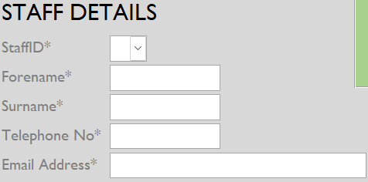

* + **Table

    Description automatically generatedStaffID -** This box is required but be aware that you can only select items from the drop-down list. You cannot enter 30, 47 etc. This can be accessed by clicking the ↓ icon on the right.
    1. When selected, the rest of the staff details will be automatically filled in.
  + **Forename** – This box is required and only allows 20 characters to be entered.
  + **Surname** – This box is required and only allows 25 characters to be entered.
  + **Telephone No** - This box is required and only accepts a certain format. In this case, 00000 000000 – this means that you must enter 11 required numbers. Including the space, only 12 characters can be entered.
  + **Email** **Address** - This box is required and only allows 40 characters to be entered.

1. **Order details**
   * Table

     Description automatically generated**ProductID** - This box is required but be aware that you can only select items from the drop-down list. You cannot enter 89, 255 etc. This can be accessed by clicking the ↓ icon on the right.
     1. When selected, the rest of the order details will be automatically filled in.
   * **Quantity** – This box is required. Only numbers can be entered, and you cannot enter a quantity more than 100 or 0. This box is automatically filled in when selecting a ProductID with a default number of 1.
   * **DishName** – This box is required and only allows 50 characters to be entered.
   * **Price** – This box is required and only accepts a certain format. In this case, currency e.g., £4.00. As such, only numbers can be entered.
   * **DishType** - This box is required but be aware that you can only select items from the drop-down list. You cannot enter Meat, Appetiser etc. This can be accessed by clicking the ↓ icon on the right.
   * **Calories** – This box is required. Only numbers can be entered, and you cannot enter more than 10000 calories.
   * **VeganSuitable -** This is a tick box that only accepts Yes/No. It should be automatically ticked if the dish is suitable for vegans, otherwise it should be unticked if it’s not.
   * **GlutenFree -** This is a tick box that only accepts Yes/No. It should be automatically ticked if the dish is gluten free, otherwise it should be unticked if it’s not.
   * **ContainsMilk** - This is a tick box that only accepts Yes/No. It should be automatically ticked if the dish contains milk, otherwise it should be unticked if it doesn’t.
   * **Item Total** – This is automatically calculated by the system depending on the price of the dish and the amount ordered. For example, a garden salad costs £4 and two have been ordered; this means the item total will be £8.
2. **Order totals**
   * 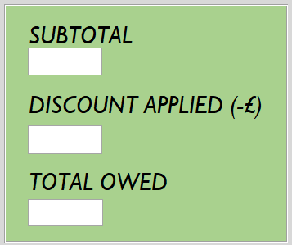**Subtotal** – This is automatically calculated by the system depending on how much has been ordered. For example, the item totals of 2 cheese and aubergine lasagnes, 2 semi-skimmed milk, and 1 lemon and vegan chocolate mousse will be totalled to give £41.40.
   * **Discount Applied (-£)** – This is automatically calculated by the system depending on the subtotal amount and the member’s discount. For example, a subtotal of £41.40 with 30% discount means that £12.42 will be applied.
   * **Total Owed** – This is automatically calculated by the system depending on the subtotal and discount amount. For example, a subtotal of £41.40 with £12.42 discount means that the member only pays £28.98.
3. Now enter the details required using your keyboard and mouse. By the end, it should look something like this:

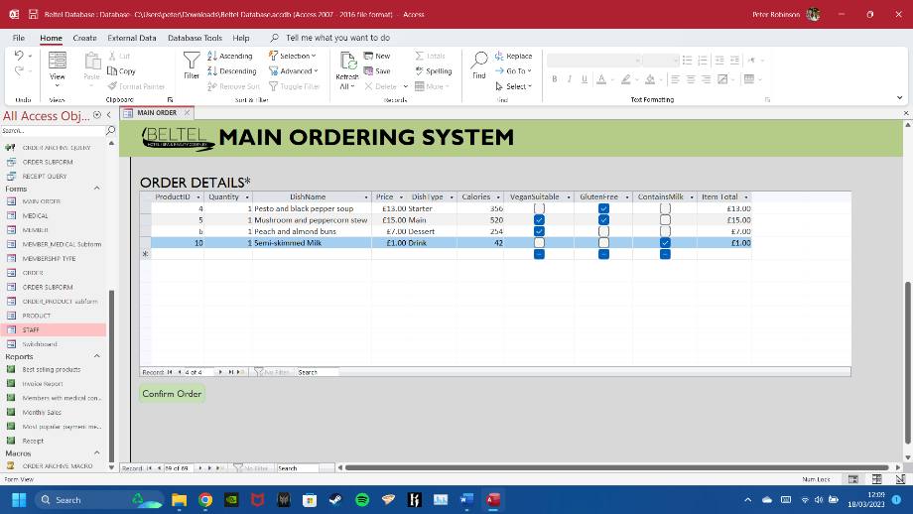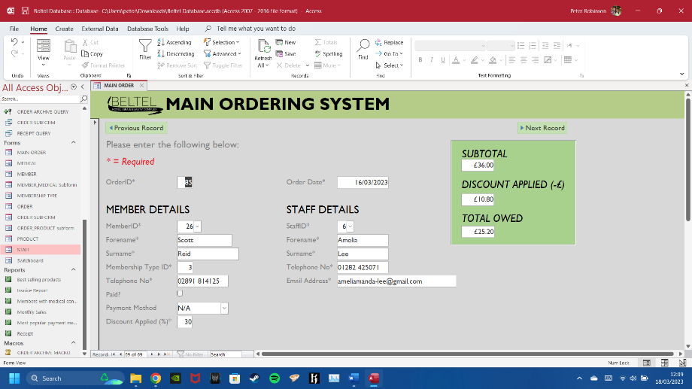

1. Now we will save this order. Located at the bottom of the form is the “Confirm Order” button. Click it, and if you’ve done everything right, it should now be stored permanently in the database.



Scott Reid’s order is now stored in the ORDER and ORDER_PRODUCT table, and (since he hasn’t yet paid) the INVOICE query.

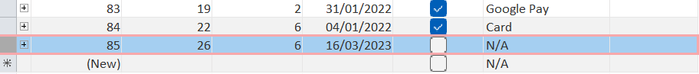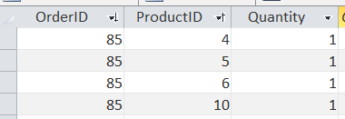

*You can return to this form by selecting “View Orders” in the Order Menu. When editing these details, they will be saved automatically – refer to the instructions above on how to do so correctly.*

## ***Adding a membership tier***

1. On the main menu, select the “Members” button.



1. You should be taken to the Member Menu. Now select “Add membership tier”.



1. Once selected, the membership form should open displaying blank boxes. Don’t enter anything just yet.

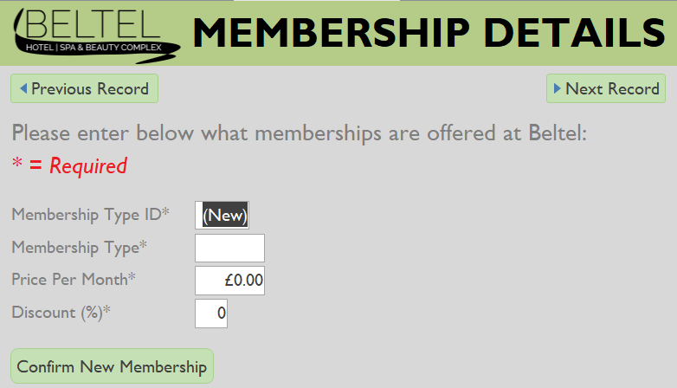

Focus your attention on the following boxes, otherwise you may receive an error message:

* **Membership Type ID** – This box is required. However, **don’t** enter anything as it will fill in automatically when entering data into the other boxes.
* **Membership Type** - This box is required and only allows 10 characters to be entered.
* **Price Per Month** – This box is required and only accepts a certain format. In this case, currency e.g., £4.00. As such, only numbers can be entered. You also cannot enter any price above £100.
* **Discount (%)** - This box is required. Only numbers can be entered, and you cannot enter a discount worth more than 50% or less than 10%.

1. Now enter the details required using your keyboard and mouse. By the end, it should look something like this:

1. Now we will save this membership tier. Located at the bottom of the form is the “Confirm New Membership” button. Click it, and if you’ve done everything right, it should now be stored permanently in the database.

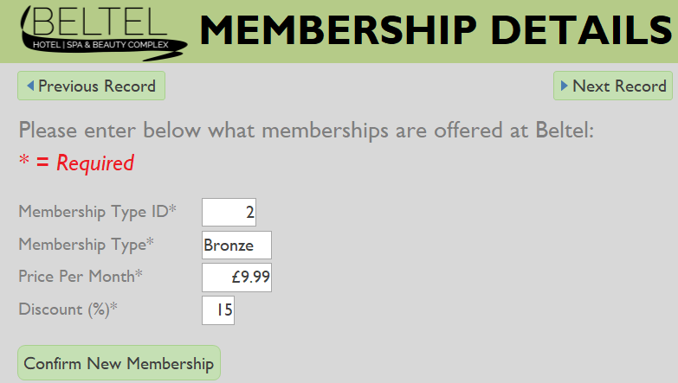

The bronze membership tier is now stored in the MEMBERSHIP TYPE table.

*You can return to this form by selecting “View membership details” in the Member Menu. When editing these details, they will be saved automatically – refer to the instructions above on how to do so correctly.*

## ***Adding a new product***

1. On the main menu, select the “Products” button.



1. You should be taken to the Product Menu. Now select “Add New Products”.

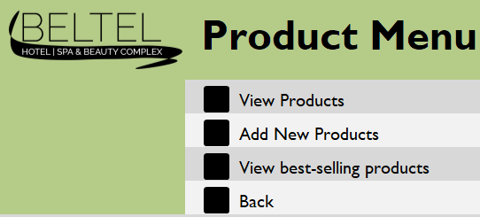

1. Once selected, the product form should open displaying blank boxes. Don’t enter anything just yet.

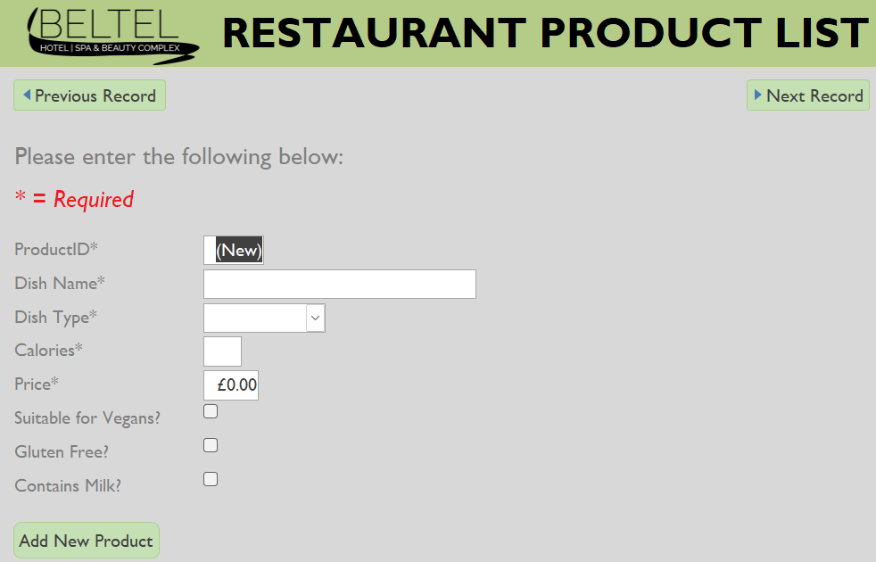

Focus your attention on the following boxes, otherwise you may receive an error message:

* **ProductID** – This box is required. However, **don’t** enter anything as it will fill in automatically when entering data into the other boxes.
  + **Dish Name** – This box is required and only allows 50 characters to be entered.
  + **Dish Type** - This box is required but be aware that you can only select items from the drop-down list. You cannot enter Meat, Appetiser etc. This can be accessed by clicking the ↓ icon on the right.
  + **Calories** – This box is required. Only numbers can be entered, and you cannot enter more than 10000 calories.
  + **Price** – This box is required and only accepts a certain format. In this case, currency e.g., £4.00. As such, only numbers can be entered.
  + **Suitable for Vegans? -** This is a tick box that only accepts Yes/No. It should be ticked if the dish is suitable for vegans, otherwise it should remain unticked if it’s not.
  + **Gluten Free? -** This is a tick box that only accepts Yes/No. It should be ticked if the dish is gluten free, otherwise it should remain unticked if it’s not.
  + **Contains Milk?** - This is a tick box that only accepts Yes/No. It should be ticked if the dish contains milk, otherwise it should remain unticked if it doesn’t.

1. Now enter the details required using your keyboard and mouse. By the end, it should look something like this:

1. Now we will save this product. Located at the bottom of the form is the “Add New Product” button. Click it, and if you’ve done everything right, it should now be stored permanently in the database.

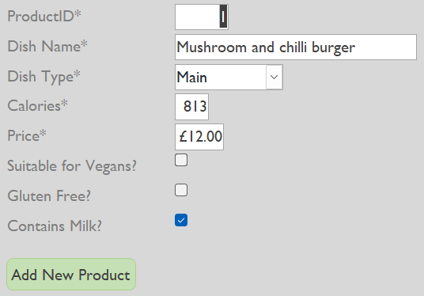

The mushroom and chili burger is now stored in the PRODUCT table.



*You can return to this form by selecting “View Products” in the Product Menu. When editing these details, they will be saved automatically – refer to the instructions above on how to do so correctly.*

## ***Adding a new staff member***

1. On the main menu, select the “Staff” button.



1. You should be taken to the Staff Menu. Now select “Add New Staff Member”.



1. Once selected, the staff form should open displaying blank boxes. Don’t enter anything just yet.

Focus your attention on the following boxes, otherwise you may receive an error message:

* **StaffID** – This box is required. However, **don’t** enter anything as it will fill in automatically when entering data into the other boxes.
* **Title** – This box **isn’t** required but please be aware that only 4 letters can be entered.
* **Forename** – This box is required and only allows 20 characters to be entered.
* **Surname** – This box is required and only allows 25 characters to be entered.
* **DOB** – This box is required and only accepts a certain format. In this case, DD/MM/YYYY (D for day, M for month and Y for year).
* **Position** – This box is required and only allows 30 characters to be entered.
* **Pay Grade Code** – This box is required but be aware that you can only select items from the drop-down list. You cannot enter £4.00, Z etc. This can be accessed by clicking the ↓ icon on the right.
  + **Telephone No** - This box is required and only accepts a certain format. In this case, 00000 000000 – this means that you must enter 11 required numbers. Including the space, only 12 characters can be entered.
  + **Email** **Address** - This box is required and only allows 40 characters to be entered.

1. Graphical user interface, text, application

   Description automatically generatedNow enter the details required using your keyboard and mouse. By the end, it should look something like this:
2. Now we will save this staff member’s details. Located at the bottom of the form is the “Add New Staff Member” button. Click it, and if you’ve done everything right, it should now be stored permanently in the database.

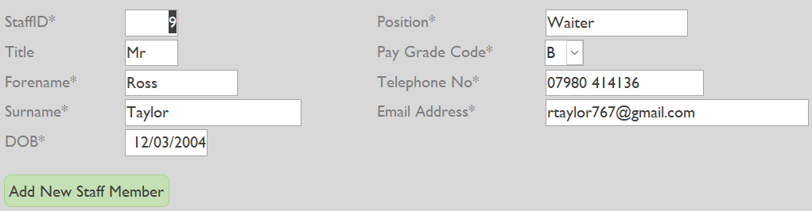

Staff member Ross Taylor is now stored in the STAFF table.

*You can return to this form by selecting “View Staff Member Details” in the Staff Menu. When editing these details, they will be saved automatically – refer to the instructions above on how to do so correctly.*

## ***Archiving orders***

1. On the main menu, select the “Orders” button.



1. You should be taken to the Order Menu. Now select “Archive Old Orders”. This should run the ORDER ARCHIVE MACRO.



1. Once selected, a message box will appear asking for confirmation before the archive process begins. Select “OK”.

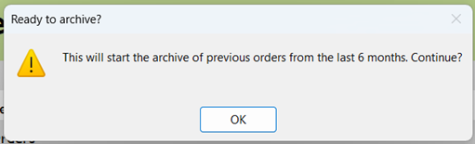

1. During this process, the system will copy orders older than six months to a new table before deleting them from their old tables. You will be asked four times to confirm these actions. Select “Yes”.

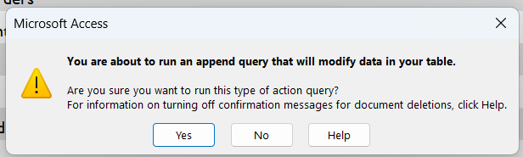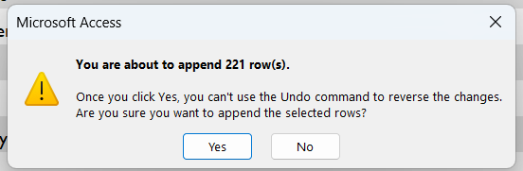

*This will copy the data to a new dedicated table.*

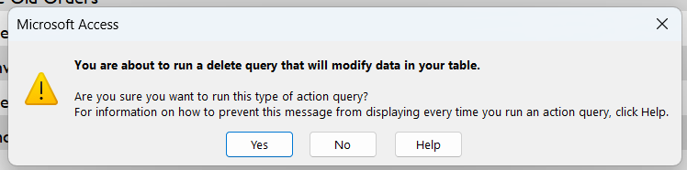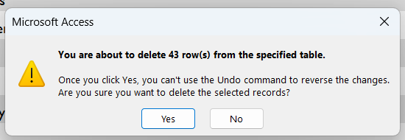

*This will delete the data from their old tables.*

1. You will know the orders have been successfully archived when another message box appears saying the archive process has been completed. To acknowledge, select “OK”.

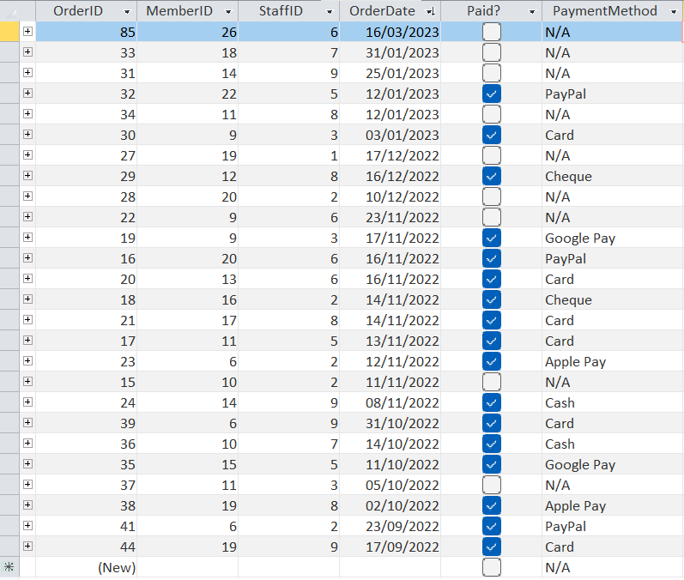

Orders older than six months have been deleted from the ORDER table.

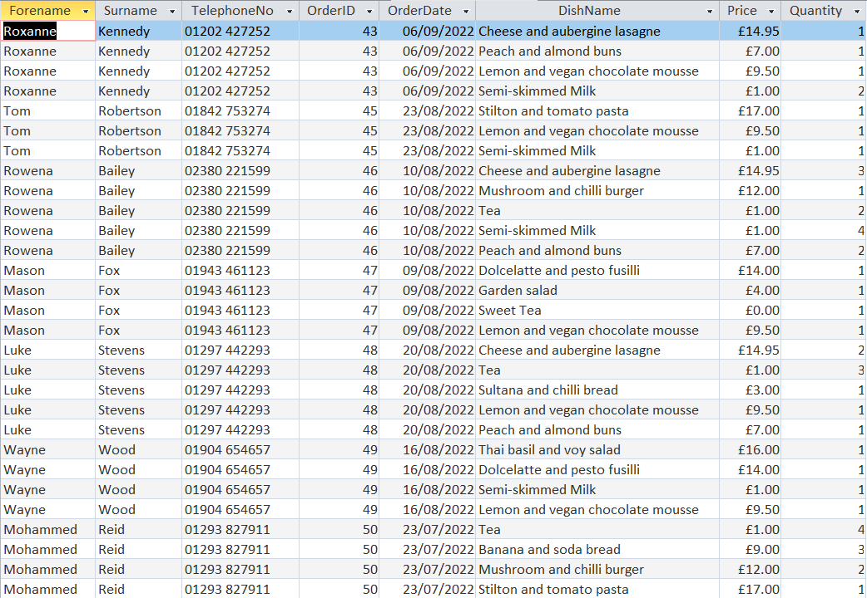

They have been copied to the ORDER ARCHIVE table.

## ***Viewing a report***

This is very simple and can be done in the same way for all reports. In this example below, we will view the restaurant’s monthly sales for 2022.

1. On the main menu, select the “Orders” button.



1. You should be taken to the Order Menu. Now select “View Restaurant Performance”.



1. In some cases (but not always), a message box may appear and ask you to enter a particular value. Here, the system is asking you to enter a specific year. Enter “2022” or another relevant year in the box provided.

1. This should open the monthly sales report displaying the total sales for each month of the year and the grand total.

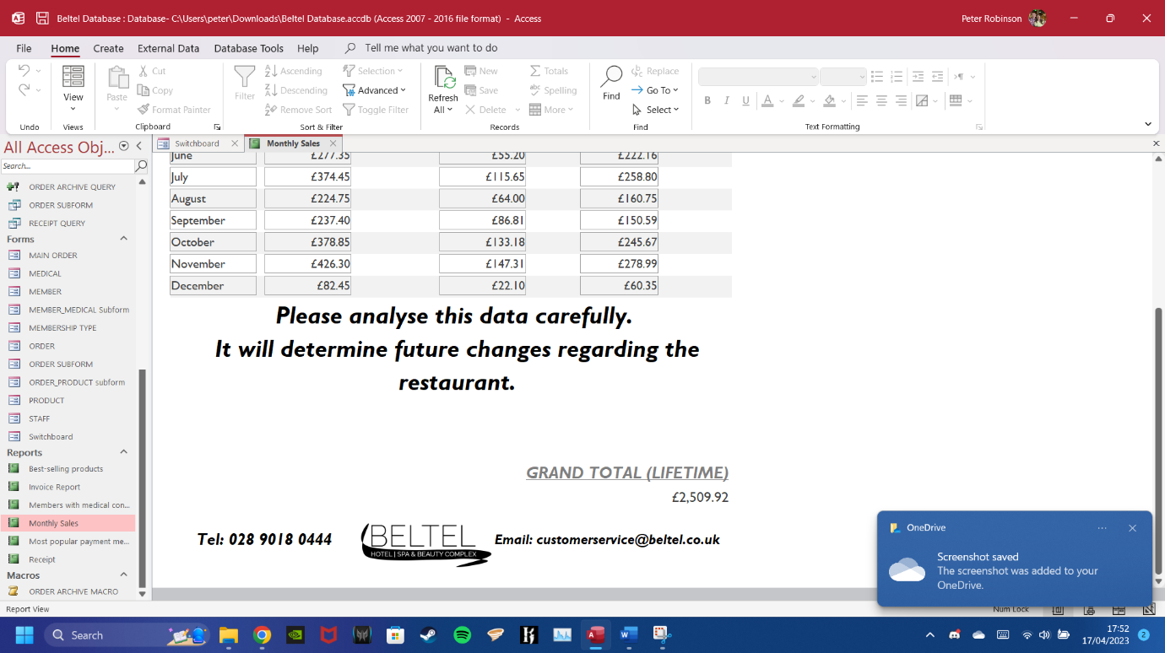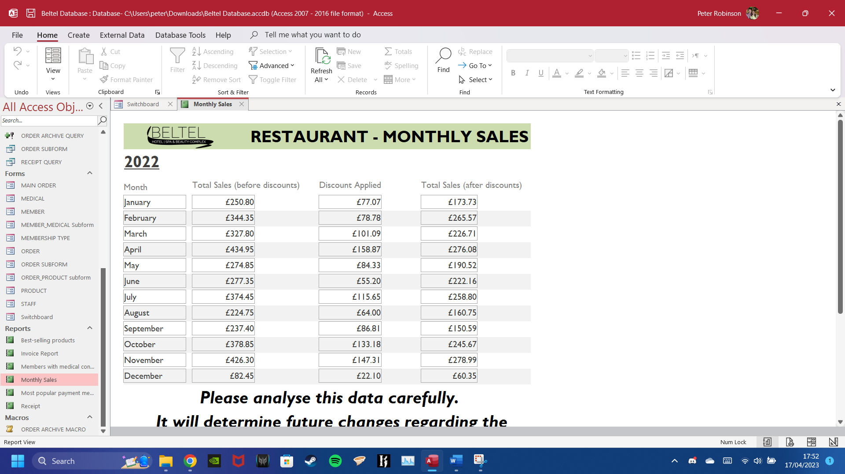

1. Table

   Description automatically generated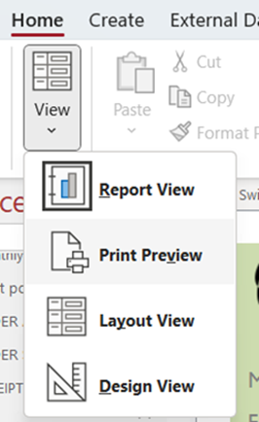To be able to zoom in/out and view multiple pages, select the “Home” tab followed by “View” then “Print Preview”.



You can select from a range of viewing options here.

1. If there are multiple pages of reports, you can use the navigation buttons located at the bottom of the screen to view different pages that are sorted from earliest to latest.



First page

Last page

Previous page

Next page

## ***Printing a report***

To print a report, first follow the instructions above. When displaying a report in Print Preview, ensure that the “Print Preview” tab is open, locate and then select “Print”.

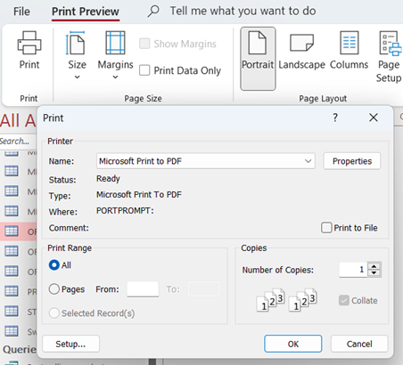

Here, you can select the desired printer in the list given, the number of copies and the page size (the default is A4). Once ready, select “OK” and it should be sent to printer to be printed.

If you wish to print a specific number of pages, select the “Pages” option button, then enter the boxes describing what pages you’d like to print. If you’d like to print a single page, enter the same number in both boxes.

# **Frequently Asked Questions**

**Q1: How do I access the menu if it doesn’t appear when the system is opened?**

A: On the left-hand side of the screen is what is called the Navigation Pane – this displays the list of tables, queries, forms, reports etc. that are stored in the database. Under the “Forms” section, locate the item named “Switchboard”. Double-click it, and the Main Menu should open.

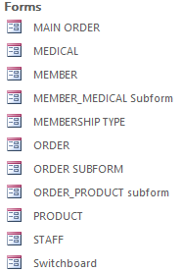



**Q2: When I try to complete a form, an error message appears asking me to enter data into a box. What’s happened?**

A: A required box has been left blank. As a result, the data you’ve entered won’t be stored until that box has been filled in. Please refer to page 13 – 32 of this guide on how to enter data depending on what field you’ve been told to fill in.

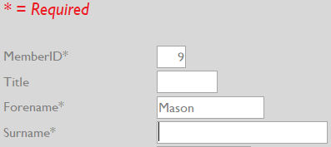

You can also check for required boxes by searching for a star symbol beside them.

A typical error message may be “Please enter _____”.

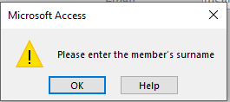

**Q3: When I try to enter a member’s title, it won’t allow me to type more data beyond a certain length. What should I do?**

A: Some boxes can only be up to a certain length. When you cannot enter anymore data into a box, that’s when you’ve entered the maximum number of characters for that box. In this case, only 4 characters can be entered into the “Title” box. To fix this, shorten the titles such as Professor to Prof, or Mister to Mr.

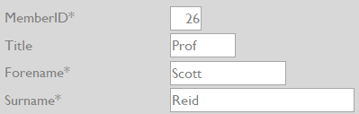

Like this! Now, the data should be accepted.

**Q4: When I try to enter an order date, an error message appears telling me that what I’ve entered isn’t valid. What should I do?**

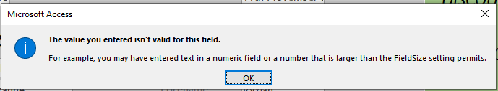A: The data must be entered in the format DD/MM/YYYY (D for day, M for month and Y for year). You cannot enter letters into this box which is what happened here. For example, instead of 12th November 2022, enter 12/11/2022 and the data should be accepted.



Like this!

**Q5: When I try to enter a member’s date of birth, an error message appears telling me that the member must be over 18. Why is that?**

A: One of the requirements to join Beltel is that they must be 18 years old or over. The system checks the member’s DOB to verify this requirement. If this message appears, underage members must be rejected from joining until they turn 18.

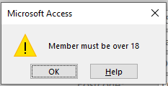

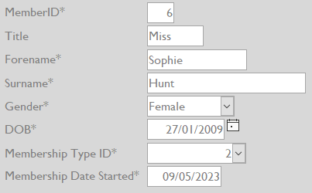

For example, this member is only 14 years old.

**Q6: When I try to enter a membership discount, an error message appears telling me that the discount must be between 10 - 50. What’s happened?**

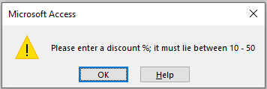A: Some boxes only accept a certain range of data. In this case, you have entered a number less than 10 or more than 50; it won’t accept a 5% or 80% discount, for example. Boxes accept different ranges of data, however, so it is recommended that you refer to page 13 – 32 of this guide for information on other fields.



This data will be accepted because it is within the range…



…whereas this data won’t.

**Q7: When I try to enter a pay grade code, an error message appears telling me that what I’ve entered isn’t valid. What’s happened?**

A: Some boxes only accept data from a list. As a result, you’ve entered data that’s not on the list which caused the error to appear. You will know when a box uses a list if there is a ↓ icon to the right.

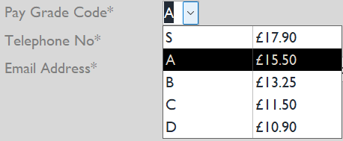

The pay grade code box accepts values S - D.

**Q8: I was trying to enter a member’s forename to process an order, but nothing appeared. Instead, I kept hearing an error sound. What should I do?**

A: For the order and member forms, you cannot enter data in boxes that will be automatically filled in. In this case, you have not selected a member ID from the drop-down menu. You can do this by clicking the ↓ icon to the right of the MemberID box and choosing your member there. Their details should fill in automatically.

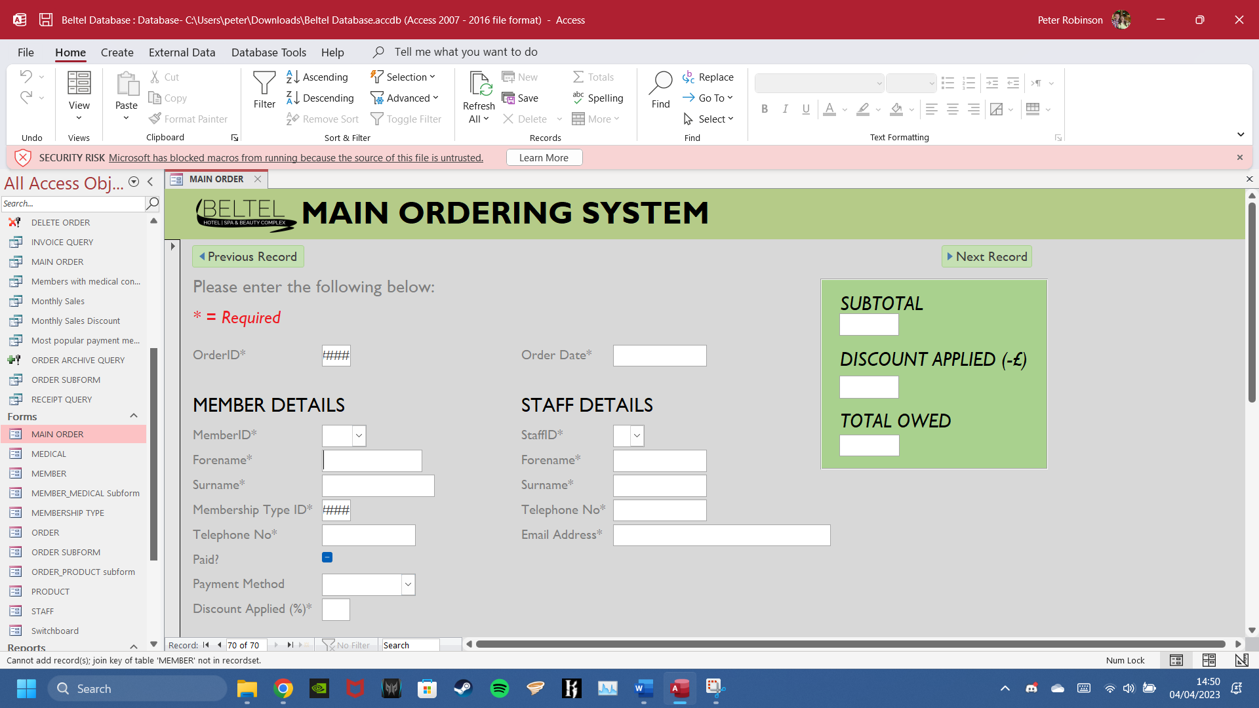

This message will appear near the bottom of your screen.

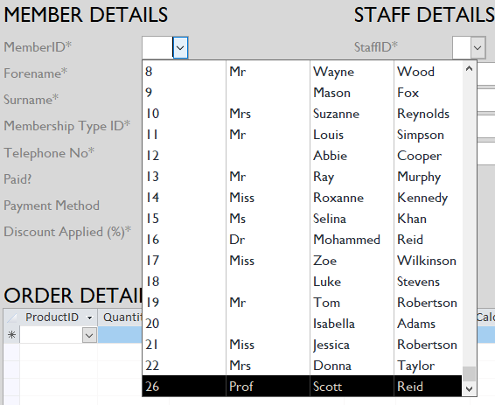

Choose who is ordering here – don’t type their name!

# **Contact details**

If you need any help regarding the system, please don’t hesitate to contact us by…

Email: systemhelp@beltel.co.uk

Telephone: 028 9018 0444

Website: www.beltelbelfast.co.uk